End User Testing: Standalone Online Course Version
Directions: It is a best practice to have a reviewer go through your course to check it from a Learner’s perspective. Contact T&OD to have yourself, and whoever else will be reviewing your course, added to the “internal” audience temporarily. They will place a checkmark next to each item that is built/working correctly. If an item is missing or not functioning properly, they will note this in the space provided. You will use this form to correct/update your online course.
Course Code and Name of Online Course being checked:
Reviewer name:
Today’s date:
Searching
Items to Check | Comments
I can locate the training using the Activity Search box.
Upon locating the training, I see the following information:
Correct name
Correct course code (UF_ABC123_OLT)
Correct course description

When I click the course name, I am taken to the Activity Summary page where I can see the following:
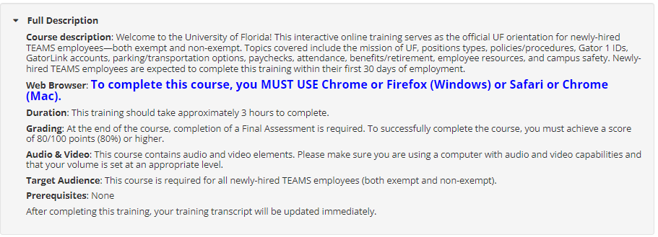
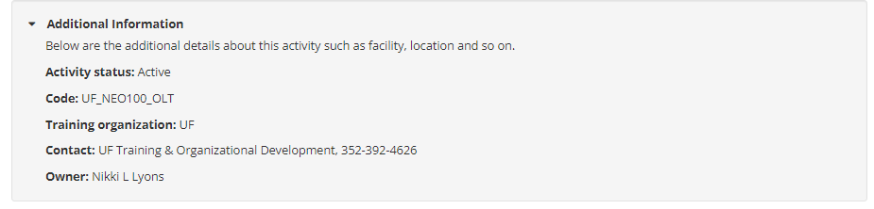

The Contact field appears and displays the following at least your department and phone number.
The Library Details field shows the various categories the training has been assigned.

The Prerequisites field appears showing appropriate information. NOTE: This field will NOT appear if the course has no prereqs.

Starting/Ending the Course
Items to Check | Comments
The SCORM package plays in a new tab.
Only elearning application-produced navigation menus and buttons appear on the course interface.
I have clicked all links/buttons in the course and there is nothing broken.
I am able to navigate to the last page of the course.
For standalone courses without internal assessments, the last page of the course includes standard verbiage related to successfully completing the course and a “Update Transcript” or “Close” type of button.
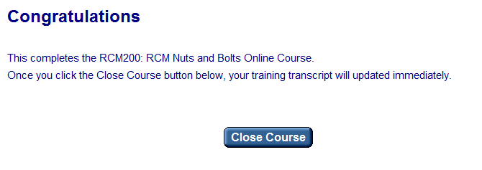

For standalone courses with internal assessments, the being assessment page includes standard verbiage related to successfully completing the final assessment, the required minimum percentage needed and a button/link to being the internal assessment. Example:
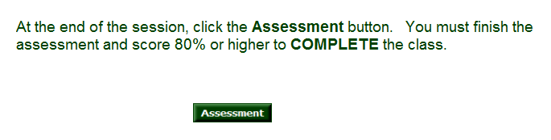
The course provides feedback on which questions the participant got right and wrong typically as a percentage.
When I click the Close button, the course content closes, and I am returned to the Activity Details page.
The “Required by Parent” verbiage does NOT appear on Activity Details page.
The online course displays as “Attended” in the Training Transcript.

Design Standards
Items to Check | Comments
r Title page includes the course code and title.
r The “reason” for the course is listed, either in the target
audience or as a separate line.
Note: For compliance training add a line for why required: "state laws to receive this training/ BOG mandated all employees take"
r Course is easily navigable forwards and backwards.
r Learning Objectives are clearly stated at the beginning of the course.
r All buttons work correctly.
r Accessibility standards
r First slide has a screen reader and next button.
r Accessibility slide with a PDF of the course and screen reader
button is provided at the beginning of course (for Articulate
Storyline and Adobe Captivate).
r Accessibility descriptions are on next, back, menu, or any
other buttons (for Articulate Storyline and Adobe Captivate).
r Transcript or closed captioning is included with any audio
elements.
r Screen reader audio is set for each slide (for Articulate
Storyline and Adobe Captivate).
r Learning dependent images include accessibility descriptions
(alt tags).
r Text is readable with appropriate contrasting colors.
r No red text is used. Check against https://webaim.org/
r Hyperlinks
r Work correctly
r Open in a new browser window
r Appropriate text is linked, not the full URL
r Ensure all interactions and media elements work.
r Course contains the ability for learner to check their understanding.

Checking your Training Transcript
Items to Check | Comments
My Training Transcript should show the online course has been attended. For those with internal assessments, the achieved score should appear in the Score column as well. Example:
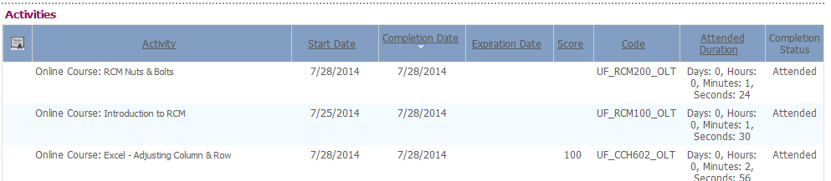

NEXT STEP for myTraining Partner:
For Courses Ready to Launch:
- If there are NO issues with this course, please contact T&OD at training@ufl.edu with the Subject Line of [Your Name], [Name and Activity Code of Course] to flip the audience.

