# Awards and Honors Section Overview

This section includes one subsection that is editable.

|  |  |  |  |
| --- | --- | --- | --- |
| Subsection | Editable | Input Method | Imported Source (if applicable) |
| Awards and Honors | Yes | Self-entered, Imported | AcA |

**NOTE:** The Awards and Honors section includes both imported and self-entered entries. Faculty members can freely add, edit, and update records. This section is unique in that it has only one subsection, which shares the same name: Awards and Honors.

**NOTE:** There are often two scroll bars: one for the main page and another for the specific section you are navigating in the Faculty Insight platform. Also, please refer to your Associate Dean for any discipline specific questions.

# Awards and Honors Subsection - Key Terms

Awards and Honors:This section encompasses the various recognitions and accolades received by faculty members for their achievements in teaching, research, service, or professional development.

## Awards and Honors Section Navigation:

1. **Log in:** Enter the Faculty Insight portal. See [Navigation Guide](https://training.hr.ufl.edu/instructionguides/fea/FEA-General-Navigation-Guide-1.pdf) for login instructions.
2. **Navigate to Activity Manager and Select Section:** Activities > Activity Manager > Awards and Honors

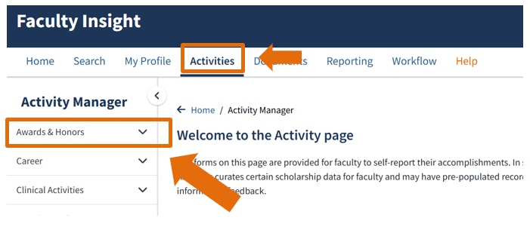

1. **Use dropdown menu:** The Awards and Honors section only has one subsection. It can be accessed using the arrow icon next to the ‘Awards and Honors’ section.

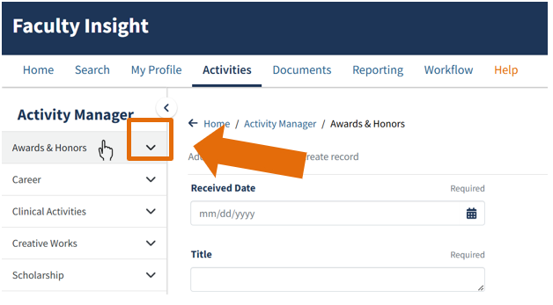

**NOTE**: While all sections have shared navigation features, there are a few that are unique to each section. The rest of this guide will focus on features and key terms unique to the Awards and Honors section. See [Navigation Guide](https://training.hr.ufl.edu/instructionguides/fea/FEA-General-Navigation-Guide-1.pdf) for how-to steps that apply universally for all sections.



## Awards and Honors Subsection

1. **Choose Awards and Honors subsection:** Use the expanded view of the Awards and Honors section.
2. **Click**: Create a Record (This will take you to fill out the required.[See the Navigation Guide.](https://training.hr.ufl.edu/instructionguides/fea/FEA-General-Navigation-Guide-1.pdf))
3. **Fill in required information**: Create a record in the Awards and Honors subsection by completing fields provided (subsection has the same name as the main section).

**NOTE**: The FEA system will not automatically deduplicate (Remove duplicate copies of data). For continuous feed it should be corrected at the source. Any edits have to be manually done.

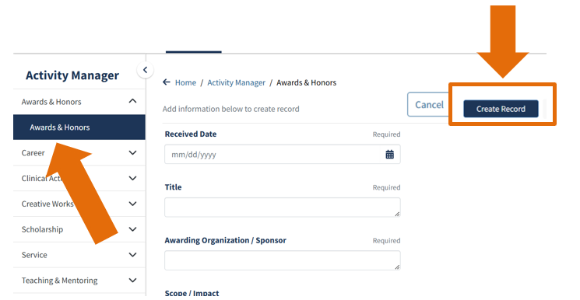

1. **Organizational Information:** After you input the required details (such as dates, title, and awarding organization/sponsor), proceed to the **Scope/Impact** dropdown to specify the reach or influence of the award.

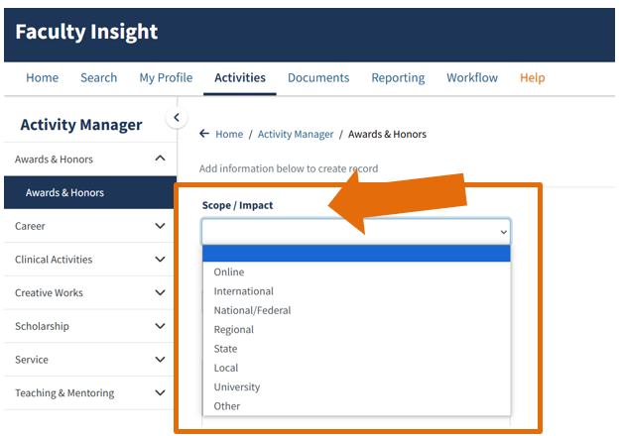

1. 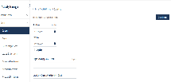**Scope/Impact Key Terms:** Refer to the following terms to see which ones best fit your entries (These will assist in organizing your work effectively).

* Online: Please DO NOT use this option.
* International: Choose this for awards and honors recognized or applicable across multiple countries.
* National/Federal: Use this for awards and honors with nationwide recognition within the United States.
* Regional: Select this for awards and honors relevant to a specific region or area.
* Local: Choose this for awards and honors that apply within a city or community.
* University: Use this for awards and honors issued by or specific to a university or academic institution.
* Other: Select this for awards and honors that do not fall under the other categories.

1. **Complete Remaining Information:** Fill out the remaining fields, such as URL/Link and Description based on the details of your awards and honors. Proceed to the Community-Engaged Activity and Type of Recognition fields.

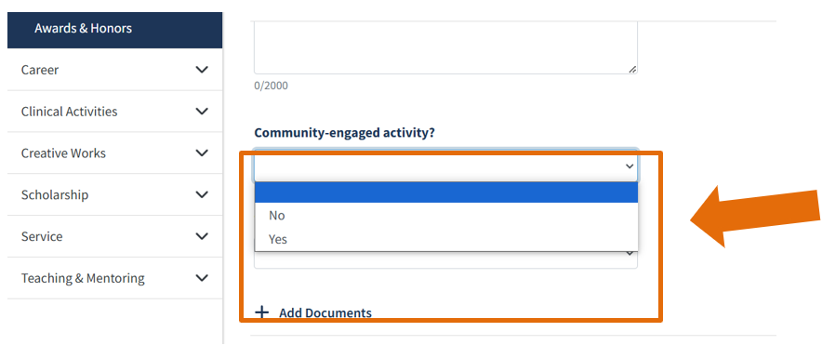

**NOTE:** Select Yes if the award or honor is associated with an activity or achievement that involved collaboration with or service to a community outside the university. Community engagement describes collaboration between institutions of higher education and their larger communities (local, regional/state, national, global). Select No if the award or honor is not related to a community-engaged activity.

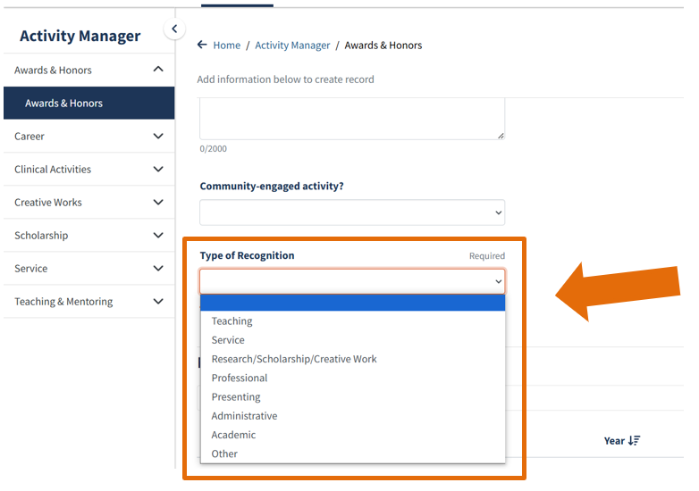

1. **Select the Type of Recognition:** Refer to the following terms to see which ones best describes the nature of the award or honor (These will assist in organizing your work effectively).
   * Teaching: Recognition for excellence in teaching or instructional activities.
   * Service: Recognition for contributions in service to the institution, profession, or community.
   * Research/Scholarship/Creative Work: Recognition for achievements in research, academic scholarship, or creative endeavors.
   * Professional: Recognition for contributions to or achievements within your professional field.
   * Presenting: Recognition for delivering presentations, talks, or workshops at conferences, seminars, or events.
   * Administrative: Recognition for administrative or leadership roles and contributions.
   * Academic: Recognition for academic achievements, such as honors for degrees or scholarly accomplishments.
   * Other: Select this option if the recognition does not align with any of the specified categories. If Other is selected, you will need to specify the appropriate label in the text box provided.
2. **Click:** Create Record to save your entry. Once saved, this will give two options in another box: Create New Record or Manage Your Records. ([See the Navigation Guide.](https://training.hr.ufl.edu/instructionguides/fea/FEA-General-Navigation-Guide-1.pdf))
3. **Continue** to the next section.

# For additional Assistance

**Policies & General Questions**

Office of the Provost | Academic and Faculty Affairs

[UF-FEA@ufl.edu](mailto:UF-FEA@ufl.edu)

**Technical Issues**  
Academic Analytics  
[facultyinsightproductquality@academicanalytics.com](mailto:facultyinsightproductquality@academicanalytics.com)